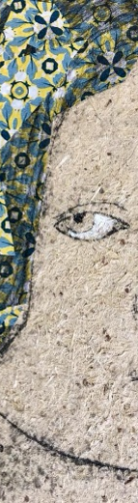
I am CELISE

Sustainable production of Cellulose-based products and additives to be used in SMEs and rural areas

Title of the meeting: minutes

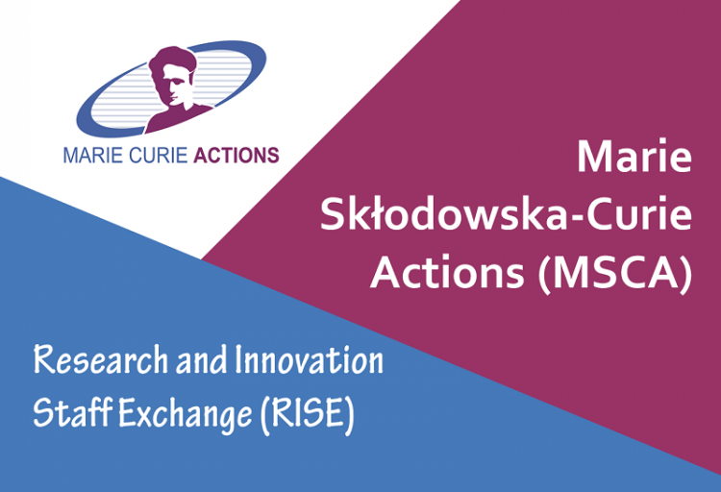
This project has received funding from the European
Union’s Horizon 2020 research and innovation
programme under the Marie Sklodowska-Curie grant
agreement No 101007733

CELISE: Sustainable production of Cellulose-based products and additives to be used in SMEs and rural areas

Title of the meeting: minutes

Date:
Place:
Chair:

PROPRIETARY RIGHTS STATEMENT
This document contains information, which is proprietary to the CELISE Consortium. Neither this document nor the information contained herein shall be used, duplicated or communicated by any means to any third party, in whole or in parts, except with prior written consent of the CELISE Consortium. In addition to such written permission to copy, reproduce or modify this document in whole or part, an acknowledgement of the authors of the document and all applicable portions of the copyright must be clearly referenced.

- Participants of the Consortium
Country | Partner | Logo | Name/s and email/s | Means
ES | UC | 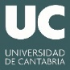 |  | On-line: Teams
ES | UPM |  |  | On-line: Teams
LV | LS-IWC | 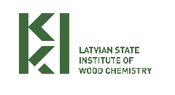 |  | On-line: Teams
PL | SGGW |  |  | On-line: Teams
PL | LUT |  |  | On-line: Teams
NO | NIBIO | 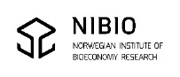 |  | On-line: Teams
GR | AUTH |  |  | On-line: Teams
GR | ECORES |  |  | On-line: Teams
CZ | INOCURE |  |  | On-line: Teams
UK | BANGOR |  |  | On-line: Teams
UK | TWI |  |  | On-line: Teams
UK | CCC |  |  | On-line: Teams
CO | UCC | 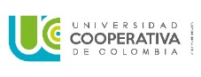 |  | On-line: Teams
EC | UNACH |  |  | On-line: Teams
AR | UNL-FICH |  |  | On-line: Teams

- TABLE OF CONTENTS

1. TABLE OF CONTENTS 4
2. PLANNED AGENDA 5
3. deviations from the planned agenda 6
4. SUMMARY OF THE MEETING 7
5. POST MEETING ACTIONS 8

- PLANNED AGENDA
Text

- deviations from the planned agenda
Text

- SUMMARY OF THE MEETING
Text

- POST MEETING ACTIONS

….

